Windows PowerShell

Introduction
PowerShell is a cross-platform task automation tool combining a command-line shell, scripting language, and configuration management framework. It’s object-oriented (handles complex data types) and built on the .NET framework, unlike text-based CMD, which only processes plain text. Initially created for Windows, it now supports macOS and Linux.

PowerShell Basics

Launching PowerShell
There are many ways to launch PowerShell on Windows system from the graphical Interface (GUI):

- Start Menu: Type powershell in the Windows Start Menu search bar, then click on Windows PowerShell or PowerShell from the results.
- Run Dialog: Press Win + R to open the Run dialog, type powershell, and hit Enter.
- File Explorer: Navigate to any folder, then type powershell in the address bar, and press Enter. This opens PowerShell in that specific directory.
- Task Manager: Open the Task Manager, go to File > Run new task, type powershell, and press Enter.
- Command Prompt: Type powershell in the Command Prompt, and press enter.

Accessing Powershell from Command Prompt
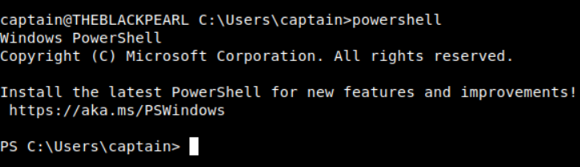
PS - stands for PowerShell

Basic Syntax: Verb-Noun
PowerShell commands are known as cmdlets (pronounced command-lets).

Cmdlets follow a consistent Verb-Noun naming convention. The Verb describes the action, and the Noun specifies the object on which action is performed. For example:

- Get-Content: Retrieves (gets) the content of a file and displays it in the console.
- Set-Location: Changes (sets) the current working directory.

Basic Cmdlets

Get-Command
- List all available cmdlets, functions, aliases, and scripts that can be executed in the current PowerShell session.
- It’s an essential tool for discovering what commands one can use.
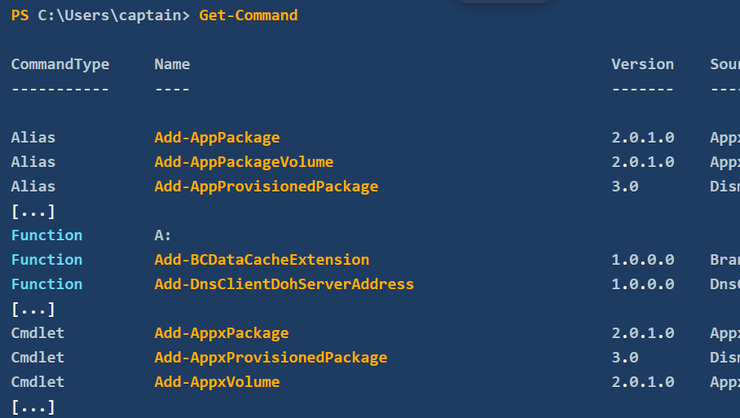

CommandInfo object
- some essential information (properties) is displayed on the console.
- To display only the available commands of type “function”, we can use -CommandType "Function"
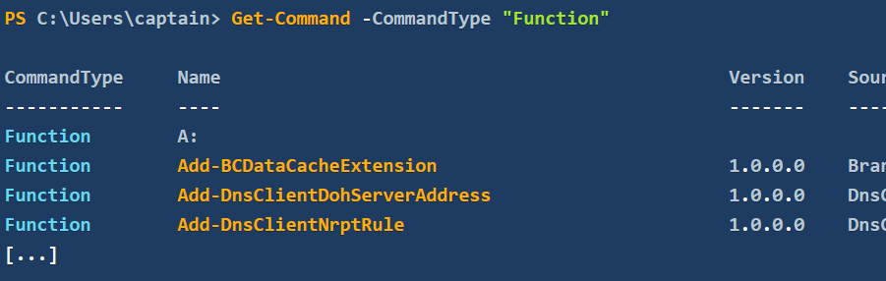

Get-Help
- Provides detailed information about the cmdlets, including usage, parameters, and examples.
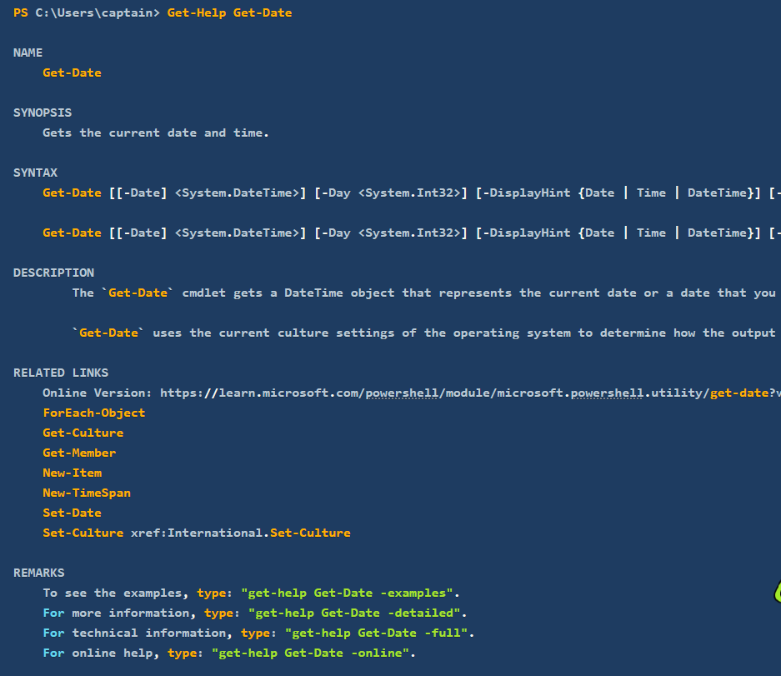

Get-Alias
- Lists all aliases available.
- For example, dir is an alias for Get-ChildItem, and cd is an alias for Set-Location.
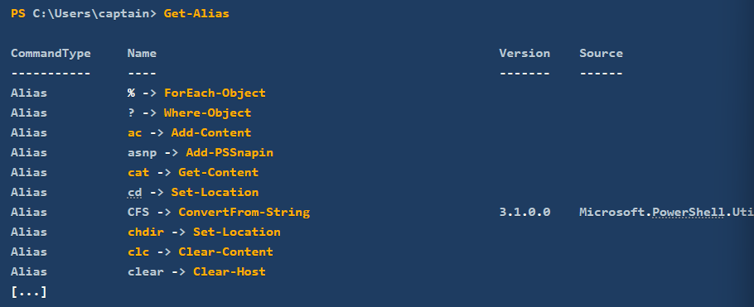

Where to Find and Download Cmdlets

Find-Module
- To search for modules (collections of cmdlets) in online repositories like the PowerShell Gallery.
- Useful to search for modules with a similar name.
- Use the following standard PowerShell syntax: Cmdlet -Property "pattern*".
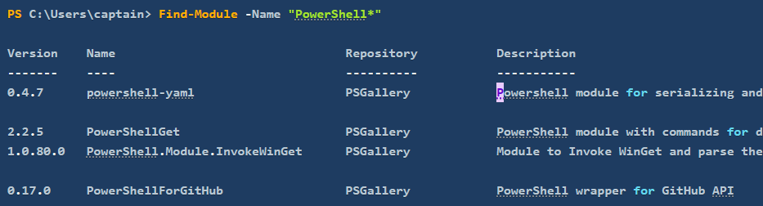
Install-Module
- Installed module from the repository, making new cmdlets contained in the module available for use.
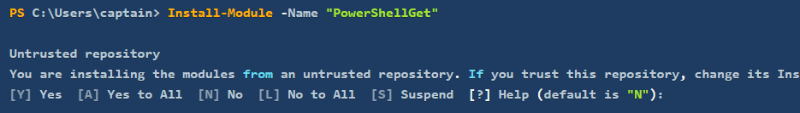

Navigating the File System and Working with Files

Get-ChildItem
- Lists the files and directories in a location specified with the -Path parameter.
- Can be used to explore directories and view their contents.
- If no Path is specified, the cmdlet will display the content of the current working directory.
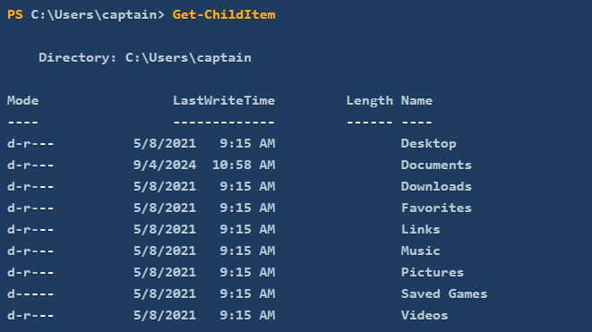

Set-Location cmdlet
- Changes the current directory.
- Similar to cd command in Command Prompt.
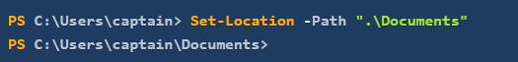

New-Item
- Create an item in PowerShell.
- Need to specify the path of the item and its type (whether it is a file or a directory).
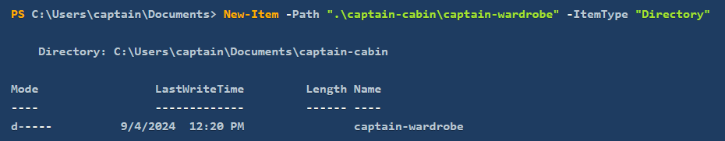
Remove-Item
- Removes both directories and files.
- Similar to rmdir and del in Windows CLI.

Copy-Item
- Copy files and directories.

Move-Item
- Move files and directories.
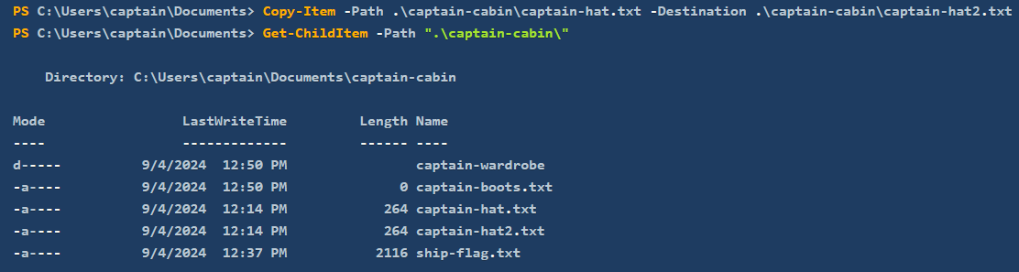

Get-Content cmdlet
- Similar to type command in Command Prompt
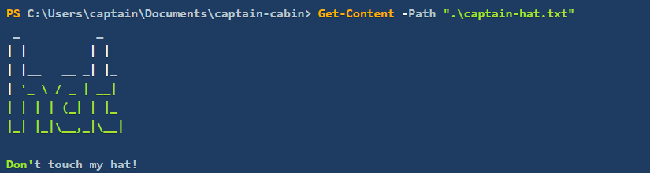

Piping, Filtering, and Sorting Data
Piping is a technique used in command-line environments that allows the output of one command to be used as the input for another. This creates a sequence of operations where the data flows from one command to the next.
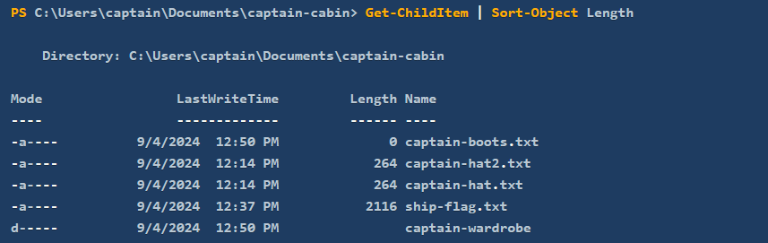
Common Commands:
- Sort-Object (sorts objects by property) – no direct CMD equivalent, similar to sort in Linux.
- Where-Object (filter objects based on conditions) – similar to grep in Linux. Where-Object filters the files by their Extension property, ensuring that only files with extension equal (-eq) to .txt are listed.
- Select-Object (select properties from objects) – used for refining output.

Example:
Get-ChildItem | Where-Object -Property Length -gt 100: List files greater than 100 bytes in size.
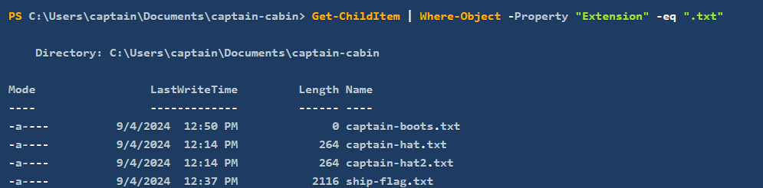

The operator -eq (i.e. "equal to") is part of a set of comparison operators that are shared with other scripting languages (e.g. Bash, Python).

PowerShell's filtering that are most useful operators:
- -ne: "not equal". This operator can be used to exclude objects from the results based on specified criteria.
- -gt: "greater than". This operator will filter only objects which exceed a specified value. It is important to note that this is a strict comparison, meaning that objects that are equal to the specified value will be excluded from the results.
- -ge: "greater than or equal to". This is the non-strict version of the previous operator. A combination of -gt and -eq.
- -lt: "less than". Like its counterpart, "greater than", this is a strict operator. It will include only objects which are strictly below a certain value.
- -le: "less than or equal to". Just like its counterpart -ge, this is the non-strict version of the previous operator. A combination of -lt and -eq.

Another example shows that objects can also be filtered by selecting properties that match (-like) a specified pattern:
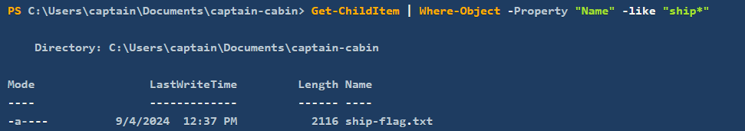

Select-Object
- Used to select specific properties from objects or limit the number of objects returned.
- It’s useful for refining the output to show only the details one needs.
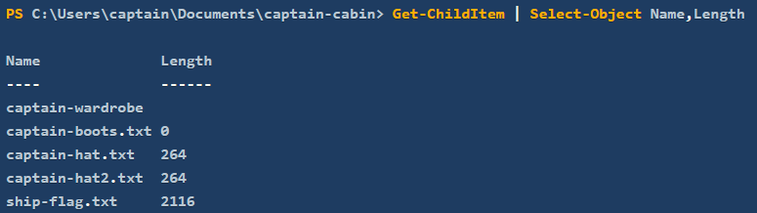

Exercise: build a pipeline of cmdlets to sort and filter the output with the goal of displaying the largest file in the C:\Users\captain\Documents\captain-cabin directory.
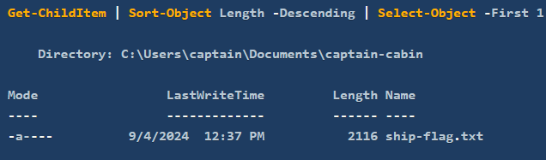

Select-String
- Search for text patterns within files, similar to grep in Unix-based systems or findstr in Windows Command Prompt.
- It’s commonly used for finding specific content within log files or documents.

System and Network Information
Get-ComputerInfo
- Retrieves comprehensive system information, including operating system information, hardware specifications, BIOS details, and more.
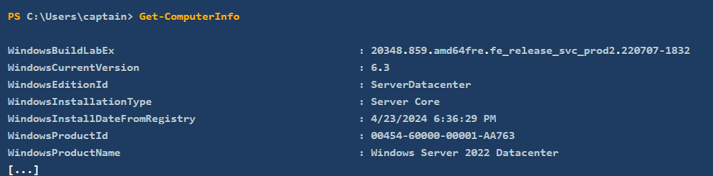

Get-LocalUser
- Lists all the local user accounts on the system.
- The default output displays, for each user, username, account status, and description.
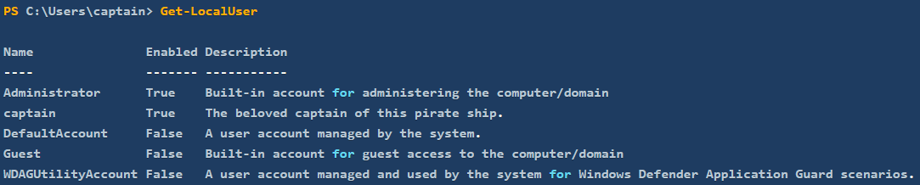

Similar to ipconfig command, the following two cmdlets can be used to retrieve detailed information about the system’s network configuration.
- Get-NetIPConfiguration provides detailed information about the network interfaces on the system, including IP addresses, DNS servers, and gateway configurations.
- Get-NetIPAddress cmdlet will show details for all IP addresses configured on the system, including those that are not currently active.
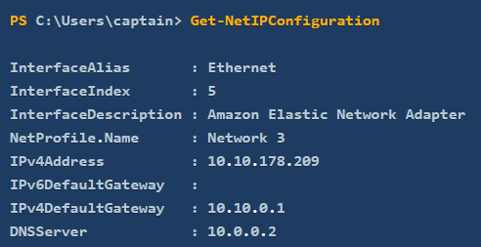
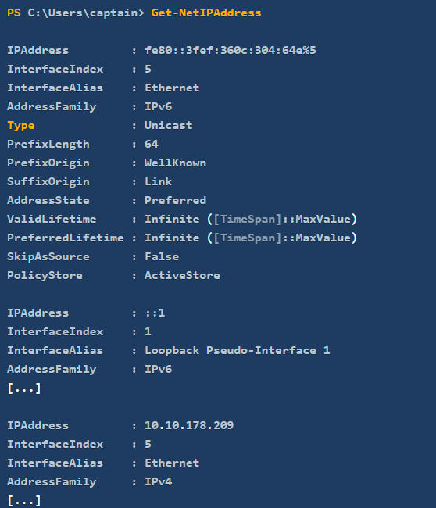

Real-Time System Analysis
Get-Process
- Provides a detailed view of all currently running processes, including CPU and memory usage, making it a powerful tool for monitoring and troubleshooting.
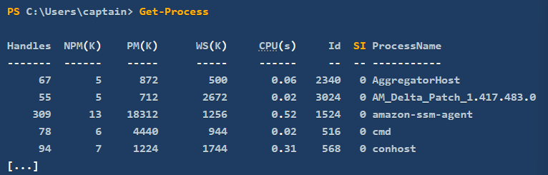

Get-Service
- Allows the retrieval of information about the status of services on the machine, such as which services are running, stopped, or paused.
- It is used extensively in troubleshooting by system administrators, but also by forensics analysts hunting for anomalous services installed on the system.
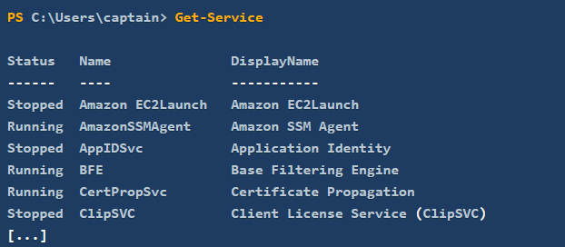

Get-NetTCPConnection
- Displays current TCP connections, giving insights into both local and remote endpoints.
- Monitor active network connections
- Useful during an incident response or malware analysis task, as it can uncover hidden backdoors or established connections towards an attacker-controlled server.
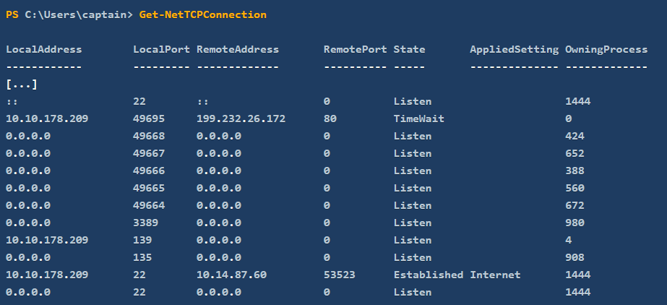

Get-FileHash
- Generating file hashes, which is particularly valuable in incident response, threat hunting, and malware analysis, as it helps verify file integrity and detect potential tampering.
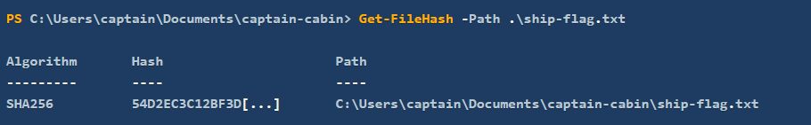

Scripting
Scripting is the process of writing and executing a series of commands contained in a text file, known as a script, to automate tasks that one would generally perform manually in a shell, like PowerShell.

Learning scripting with PowerShell goes beyond the scope of this room. Nonetheless, we must understand that its power makes it a crucial skill across all cyber security roles.

- For blue team professionals such as incident responders, malware analysts, and threat hunters, PowerShell scripts can automate many different tasks, including log analysis, detecting anomalies, and extracting indicators of compromise (IOCs). These scripts can also be used to reverse-engineer malicious code (malware) or automate the scanning of systems for signs of intrusion.

- For the red team, including penetration testers and ethical hackers, PowerShell scripts can automate tasks like system enumeration, executing remote commands, and crafting obfuscated scripts to bypass defences. Its deep integration with all types of systems makes it a powerful tool for simulating attacks and testing systems’ resilience against real-world threats.

- Staying in the context of cyber security, system administrators benefit from PowerShell scripting for automating integrity checks, managing system configurations, and securing networks, especially in remote or large-scale environments. PowerShell scripts can be designed to enforce security policies, monitor systems health, and respond automatically to security incidents, thus enhancing the overall security posture.

Invoke-Command
- Essential for executing commands on remote systems, making it fundamental for system administrators, security engineers and penetration testers.
- Invoke-Command enables efficient remote management and—combining it with scripting—automation of tasks across multiple machines.
- It can also be used to execute payloads or commands on target systems during an engagement by penetration testers—or attackers alike.
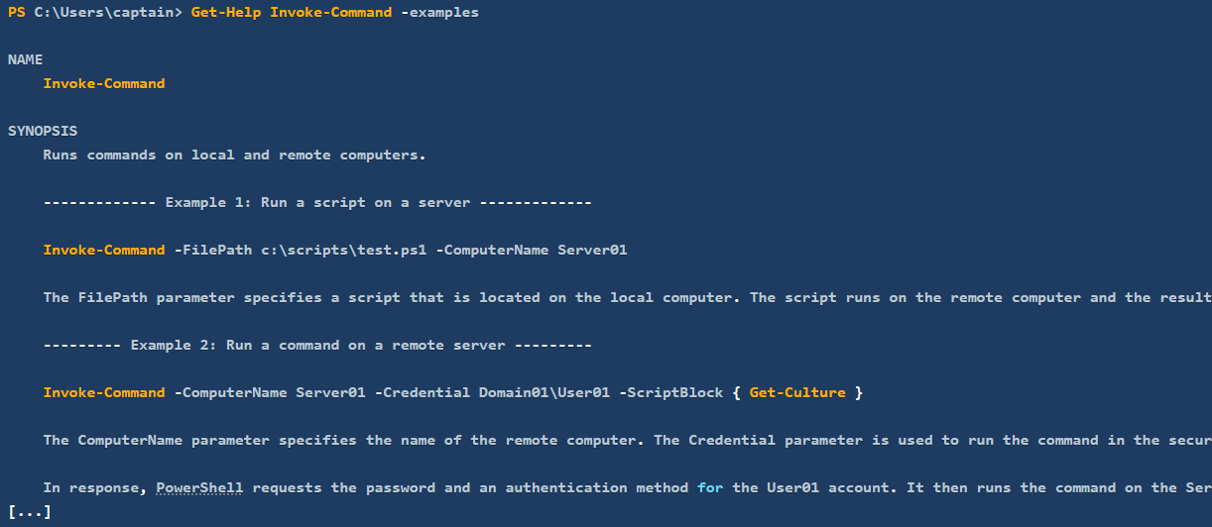
The first two examples provided by the Get-Help "examples" page and reported above are enough to grasp the simplicity and power of the Invoke-Command cmdlet.

The first example shows how the cmdlet can be very easily combined with any custom script to automate tasks on remote computers.

The second example demonstrates that we don't need to know how to script to benefit from the power of Invoke-Command. In fact, by appending the -ScriptBlock { ... } parameter to the cmdlet's syntax, we can execute any command (or sequence of commands) on the remote computer. The result would be the same as if we were typing the commands in a local PowerShell session on the remote computer itself.

